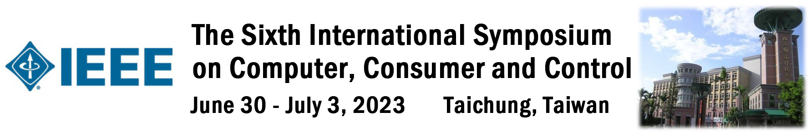
Special Sessions Call for Papers (Example)
The Sixth International Symposium on Computer, Consumer and Control, 2023

Session organizer：Prof. Sheng-Chih Yang
Institution：National Chin-Yi University of Technology
E-mail：scyang@ncut.edu.tw
Session title: System Simulation and Control
With the advancement of computer hardware providing more powerful computing environments, system simulation and control researchers have been able to challenge solving larger and more complex problems. Driven by such motivation, the innovative methodologies of system simulation and control technologies are proposed not only in area of engineering but also in new paradigms in computer science. In addition, system simulation and control researchers have applied the developed methods to various real-world problems such as robotic system. This session includes the mathematical and physical theories of the nonlinear dynamic analysis and control in physical, engineering, biological studies, and their various applications. Prospective authors are invited to submit original papers to the Special Session.

Topics/Areas
We invite academic researchers and industry professionals from a broad range of disciplines to submit to this special issue. Topics of interest include, but are not limited to:
- Electrical and Mechanical System Control
- Computer Simulation and Analysis in Nonlinear System.
- Intelligent Learning in Control Systems
- Robotics and Mechatronics
- Other System Simulation and Control Applications

All papers accepted and registered for presentation will be published in the conference proceedings, and excellent papers will be recommended for publication in the special issue of SCI(E)/ EI journals. Please note that papers must submit via the submission system website and meet the format of IS3C2023.

